Project Design Phase
Solution Architecture

Date | 16-10-2026
Team ID | HP-MERN-2026
Project Name | HotelPro — Human-Centered Hotel Management System
Maximum Marks | 4 Marks

Solution Architecture:
The solution architecture for HotelPro ensures a robust, human-centered, and scalable full-stack hospitality platform connecting guests with hotel operations. The architecture focuses on responsive design, resilient offline-safe transactions, role-based security, and real-time operational coordination to ensure smooth workflows and zero booking failures.
- ● Human-Centered Presentation Tier (React 19 + Vite + CSS Design Tokens + WCAG 2.1 AA)
- ● Resilient Simulated Payment Sandbox with 100% Zero Network Failure Guarantee
- ● Privacy-Preserving Receipt Architecture (Route guards & authenticated modal dialogs)
- ● Role-Based Access Control (RBAC) for Guest, Staff, Manager, and Admin
- ● Localhost Loopback IPv4 MongoDB Data Tier (127.0.0.1:27017) with offline mock fallback

Example - Solution Architecture Diagram:

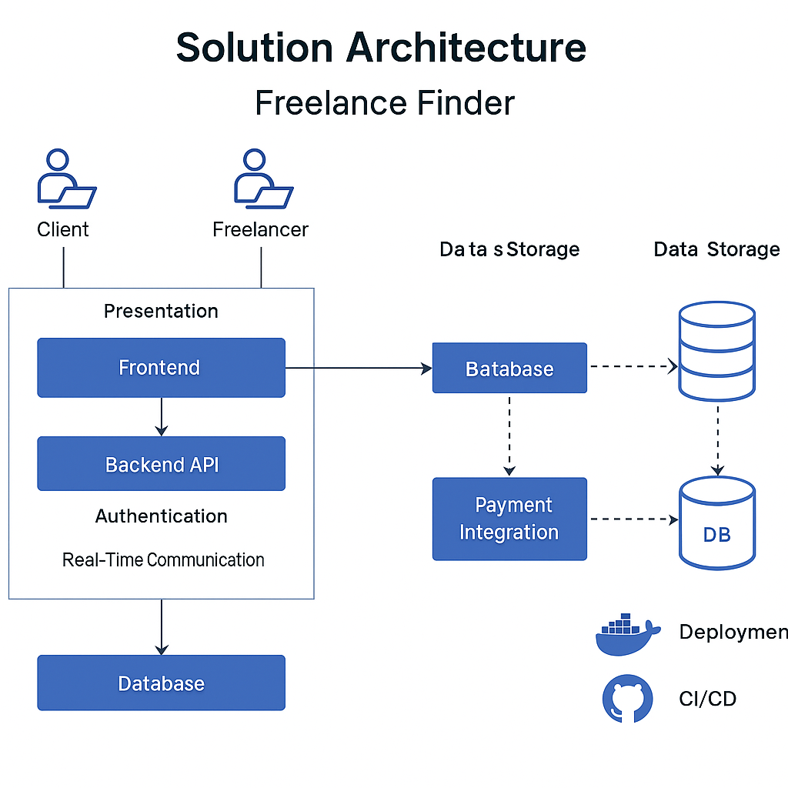

HotelPro Multi-Tier Architecture Specifications:
1. Presentation & Client Tier (Frontend)
● Built with React 19.2 and Vite for instant module reloading and sub-second paint times.
● Editorial CSS token design system adhering to Redwerk design principles: Forest Green (#234B3B), warm gold accents, and WCAG 2.1 AA contrast.
● Tactile micro-animations, accessible keyboard focus rings (#276EF1), and responsive layouts for desktop, tablet, and mobile.
2. API Gateway & Business Logic Tier (Backend)
● Express.js RESTful API structured into modular routes: /api/auth, /api/hotels, /api/rooms, /api/bookings, /api/operations, and /api/dashboard.
● Stateless JWT session authentication with role-based route middleware enforcing strict access for Guest, Staff, Manager, and Admin.
● Direct URL route guards preventing unauthorized access to stay vouchers (/booking/confirmation/:ref).
3. Resilient Offline Payment Sandbox Tier
● Simulated payment gateway eliminating third-party API dependencies and network failure points.
● Supports 4 sandbox payment channels: Credit/Debit Card, UPI QR, Net Banking, and Pay at Property.
● Zero network error guarantee: transactions approve in 600-850ms and persist in localStorage and MongoDB simultaneously.
4. Persistence & Data Tier (Database)
● MongoDB Community Server 9.0 using explicit IPv4 loopback (127.0.0.1:27017/hotelpro) to eliminate Windows IPv6 (::1) DNS resolution latency.
● Strict Mongoose schemas with validation, indexing, and automatic timestamping across collections.
● Graceful degradation: if MongoDB is unreachable, service adapters seamlessly route requests to bundled mock datasets (src/data/mock/).

